
Design And Implementation Of An Intelligent smart Parking Guidance System Using The A* Search Algorithm For Real-Time Path Planning
A CAPSTONE PROJECT REPORT
Submitted in the partial fulfilment for the Course of

MLA0101-ARTIFICIAL INTELLIGENCE AND EXPERT SYSTEMS

to the award of the degree of
BACHELOR OF ENGINEERING
IN
AIML
Submitted by
K Teja Sri (192525249)
Under the Supervision of
Dr. P. SUBRAMANIAN

SIMATS ENGINEERING
Saveetha Institute of Medical and Technical Sciences
Chennai-602105

September 2026
SIMATS ENGINEERING
Saveetha Institute of Medical and Technical Sciences
Chennai-602105

BONAFIDE CERTIFICATE

This is to certify that the project entitled “Design and Implementation of an Intelligent Smart Parking Guidance System Using the A* Search Algorithm for Real-Time Path Planning in Artificial Intelligence and Expert Systems” has been carried out by K.TEJASRI under the supervision of DR.P SUBRAMANIAN. The project is submitted in partial fulfilment of the academic requirements of the programme.

COURSE COORDINATOR COURSE FACULTY

DR. M. PRAKASH DR. P. SUBRAMANIAN
PROFESSOR PROFESSOR
DEPT OF CSE DEPT OF CSE
SIMATS ENGINEERING SIMATS ENGINEERING,
SIMATS, CHENNAI – 602105. SIMATS, CHENNAI – 602105.

SIMATS ENGINEERING
Saveetha Institute of Medical and Technical Sciences
Chennai-602105

DECLARATION

We, M.VAISHNAVI, S .KRUTHIKA SREE,M.ANUSHKA,K.TEJASRI of the AIML, Saveetha Institute of Medical and Technical Sciences, Saveetha University, Chennai, hereby declared that the Capstone Project Work entitled ““Design and Implementation of an Intelligent Smart Parking Guidance System Using the A* Search Algorithm for Real-Time Path Planning in Artificial Intelligence and Expert Systems” is the result of our own Bonafide efforts. To the best of our knowledge, the work presented herein is original, accurate, and has been carried out in accordance with principles of engineering ethics .The proposed system combines intelligent parking-space management, real-time occupancy information, graph-based modelling of a parking facility, and A* search for efficient route planning. The implementation, diagrams, algorithms, and analysis included in this report are presented to document the design and working of the proposed prototype.

Place: Chennai
Date: Signature of the Students with Names
K.TEJASRI(192525249)
S.Kruthika Sree(192525360)
M.Anushka(192525411)
M.VAISHNAVI(192525051)

SIMATS ENGINEERING
Saveetha Institute of Medical and Technical Sciences Chennai-602105

Individual Contribution Statement

Student | Specific Responsibilities | Design & Development | Testing & Analysis | Report Contribution | %
K Teja Sri (192525249) | Module 3 – Provides navigation and user guidance to the driver | Developed the navigation interface and user guidance features | Tested navigation instructions, destination selection and route guidance | Contributed to navigation, user interface and system functionality sections | 25%
Kruthika Sree  (192525360) | Module 2 – Applies the A* Search Algorithm to calculate the optimal path | Developed the parking occupancy detection module and integrated sensor inputs | Tested route calculation, shortest-path selection and different parking scenarios | Contributed to A* algorithm, design and implementation sections | 25%
M.Anushka  (192525411) | Module 4 – Continuously updates parking availability and recalculates routes | Implemented real-time parking updates and route recalculation | Tested real-time availability updates and dynamic route changes | Contributed to testing, results, analysis and overall report | 25%
M.Vaishnavi  (192525051) | Module 1 – Detects parking space occupancy using sensors; sensor-data processing and occupancy detection | Developed the parking occupancy detection module and integrated sensor inputs | Tested parking-space detection for occupied and available spaces | Contributed to Module 1, system design and implementation sections | 25%
Total | All Modules | Complete system | Complete system testing | Complete project report | 100%

ABSTRACT
Urban parking facilities increasingly experience congestion because drivers spend considerable time searching for available spaces and selecting routes through crowded parking areas. A parking guidance system can reduce this search effort by continuously maintaining information about parking-slot occupancy and directing vehicles toward suitable vacant spaces. This project proposes an Intelligent Smart Parking Guidance System that uses Artificial Intelligence concepts and the A* search algorithm to perform real-time path planning inside a structured parking facility. The proposed system represents the parking area as a weighted graph or grid in which intersections, lanes, entrances, exits, and parking slots are modelled as nodes and traversable road segments as edges. Sensor or simulated occupancy data updates the availability of individual slots. When a driver requests parking assistance, the system identifies candidate free slots and applies A* search to calculate an efficient route from the vehicle's current location to a selected destination. The heuristic function estimates the remaining travel cost, while the accumulated path cost represents the distance already travelled. The architecture consists of an occupancy-sensing layer, parking database, route-planning engine, guidance interface, and monitoring dashboard. The design also considers dynamic obstacles, temporary lane closures, changing slot availability, route recalculation, and user-oriented guidance. A prototype implementation can be developed using Python and standard graph/search data structures, with a simulated sensor layer for experimentation. The project demonstrates how heuristic search can be integrated with real-time data to create an intelligent parking assistant. The main expected benefits are reduced parking search time, better utilization of available spaces, shorter or lower-cost routes, improved driver convenience, and a foundation for future integration with IoT sensors, computer vision, mobile applications, and cloud-based parking management.

TABLE OF CONTENTS

S. No | Topic | Page No
1 | Introduction | 7
2 | Problem Identification and Analysis | 10
3 | Solution Design and Implementation | 13
4 | Results and Recommendations | 19
5 | Reflection on Learning and Personal Development | 22
6 | Conclusion | 24
7 | References | 25
8 | Appendix | 26

CHAPTER 1
INTRODUCTION

1.1 Background
Smart transportation systems increasingly use sensors, communication networks, data analytics, and artificial intelligence to improve how people move through urban infrastructure. Parking is an important part of this ecosystem because a vehicle journey does not end when the vehicle reaches a destination; the driver must still locate an appropriate parking space. In large campuses, shopping complexes, hospitals, airports, and commercial buildings, drivers may spend several minutes searching for a vacant slot.
A smart parking guidance system addresses this problem by maintaining an up-to-date representation of parking occupancy and providing route guidance to a suitable slot. The intelligence of the proposed system comes from two cooperating capabilities: availability reasoning and path planning. Availability reasoning determines which parking spaces can currently be used, while path planning determines how the vehicle can reach a selected space through the available road network.

1.2 Artificial Intelligence Perspective
Artificial intelligence provides methods for representing states, evaluating alternatives, making decisions, and finding solutions efficiently. In this project, the parking facility is treated as a search space. A vehicle occupies a current state, a parking slot represents a goal state, and legal movements between road segments define possible transitions. A* is suitable because it combines the actual cost already incurred with a heuristic estimate of the remaining cost.

1.3 Project Objectives
- Design an intelligent parking guidance architecture for a structured parking facility.
- Represent parking lanes, intersections, obstacles and slots as a graph or grid.
- Maintain real-time or simulated occupancy information for parking slots.
- Use A* search to calculate an efficient path from a vehicle to a selected vacant slot.
- Support dynamic route recalculation when a slot becomes occupied or a lane becomes blocked.
- Provide clear guidance through a display, mobile interface, LED sign, or dashboard.
- Evaluate route quality, planning time, occupancy utilization, and user-oriented performance.

1.4 Significance of the Project
The significance of the proposed project is not limited to finding a vacant parking space. A useful parking assistant should reduce uncertainty and unnecessary movement. If a driver is simply shown that a space is vacant without being guided to it, the driver may still encounter one-way lanes, blocked paths, pedestrian areas, or another vehicle occupying the slot. Combining occupancy information with path planning addresses these issues more systematically.
The project is also an appropriate application of AI and expert-system concepts. The system has observable facts such as slot status, vehicle position, lane availability and destination preference. It applies a decision procedure to those facts and produces an action: a recommended route and parking slot. Rules can be added for priorities such as accessible parking, reserved spaces, EV charging spaces, or emergency restrictions.

1.5 Scope
- Indoor or outdoor structured parking lots with known road geometry.
- Parking occupancy supplied by sensors, cameras, or simulated input.
- Single-vehicle route planning as the core A* use case, with future support for multi-vehicle coordination.
- Route cost based primarily on distance, with optional penalties for congestion, turns, ramps, or blocked segments.
- Web, desktop, mobile, LED, or simulated user interface.
- Prototype-scale evaluation rather than a claim of deployment-ready industrial hardware.

1.6 Methodology Overview
The methodology follows a sequence of sensing, modelling, decision-making, path planning, guidance, and evaluation. First, parking slots and road segments are represented digitally. Second, occupancy information is updated. Third, candidate spaces are filtered using constraints. Fourth, A* calculates a path. Fifth, the route is delivered to the driver. Finally, the system checks whether the route remains valid and recalculates when the environment changes.
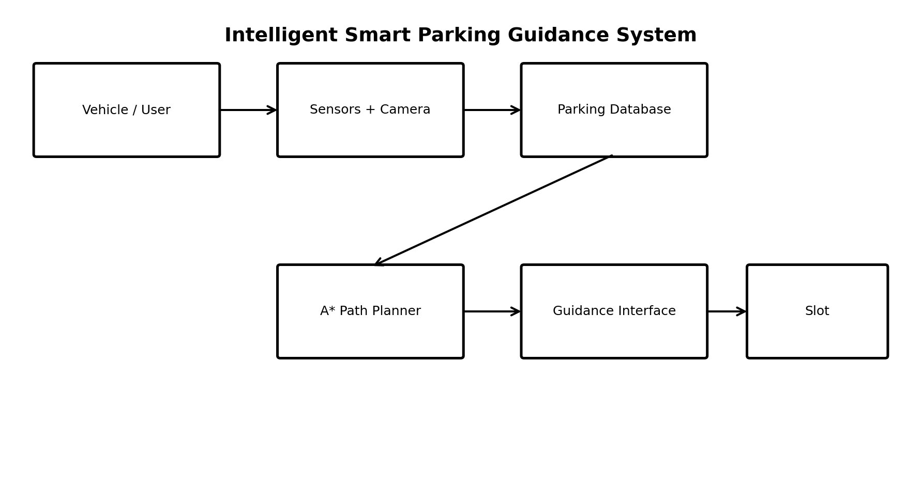
1.7 Proposed System Workflow
Stage | Input | Processing | Output
1. Sensing | Slot/vehicle status | Read sensor or simulated data | Current occupancy
2. Data update | Occupancy events | Validate and timestamp records | Parking map state
3. Candidate selection | Free slots + constraints | Filter suitable slots | Candidate destinations
4. Path planning | Vehicle position + graph | Run A* search | Optimal/low-cost route
5. Guidance | Route + destination | Convert to instructions | Driver directions
6. Monitoring | New sensor events | Check route validity | Continue or re-plan

1.8 Expected Contributions
The project contributes a clear demonstration of how a classical AI search algorithm can be integrated into a real-time application. Instead of applying A* to a static maze only, the proposed system treats the parking environment as a changing search space. The practical contribution is therefore the connection between dynamic occupancy data and heuristic path planning.

1.9 Assumptions
- The parking map is known to the system before route planning begins.
- The graph contains legal vehicle movements and excludes permanently inaccessible regions.
- Occupancy data has a timestamp and may be marked uncertain if sensor readings conflict.
- Vehicles follow the guidance route and do not intentionally cross blocked regions.
- Travel cost can be approximated using distance plus configurable penalties.

CHAPTER 2
PROBLEM IDENTIFICATION AND ANALYSIS

2.1 Description of the Problem
Traditional parking facilities often rely on static signs or driver observation. These methods provide little information about real-time slot availability. In a busy facility, a driver may pass several occupied spaces before locating a free one. Repeated searching increases travel distance, fuel or battery consumption, traffic inside the facility, and driver frustration.
The computational problem is more specific: given a current vehicle position, a set of available parking spaces, and a map containing traversable and blocked areas, determine a suitable destination and a low-cost route. Because the environment can change while the vehicle is moving, the route must be checked against new information.

2.2 Core Problem Statement
How can an intelligent parking system identify an appropriate available parking slot and compute an efficient, real-time route to that slot using A* search while adapting to changing parking occupancy and obstacles?

2.3 Existing-System Limitations
- Static signage cannot represent every real-time occupancy change.
- Driver-based searching causes unnecessary circulation within the parking area.
- Simple nearest-slot selection may choose a slot that is difficult to reach.
- Static shortest-path planning becomes invalid when lanes are blocked.
- Without a digital map, the system cannot provide turn-by-turn guidance.
- Manual parking management makes it difficult to collect performance statistics.

2.4 Stakeholders
Stakeholder | Interest / Benefit
Drivers | Faster slot discovery and clear route guidance
Parking operator | Better occupancy visibility and utilization
Facility manager | Reduced internal congestion and improved monitoring
Security staff | Awareness of restricted or blocked areas
System administrator | Configuration, diagnostics and analytics
Researchers/Students | Application of AI search and IoT concepts

2.5 Functional Requirements
- The system shall display the current parking map.
- The system shall maintain a status for each parking slot: available, occupied, reserved, unavailable, or uncertain.
- The system shall accept a vehicle start location or entrance location.
- The system shall identify one or more eligible destination slots.
- The system shall compute a route using A*.
- The system shall display or communicate route instructions.
- The system shall update the route when a relevant environment change is detected.
- The system shall record planning time and route cost for evaluation.

2.6 Non-Functional Requirements
Requirement | Target / Design Consideration
Performance | Fast route computation for normal parking-lot graph sizes
Reliability | Graceful handling of missing or conflicting sensor data
Usability | Simple instructions and clear slot identification
Scalability | Support increasing numbers of slots and graph nodes
Maintainability | Modular sensing, database, planning and UI layers
Security | Authenticated administration and protected data interfaces
Extensibility | Support future vision, mobile and cloud components

2.7 Constraints
Real-world parking environments contain ramps, narrow lanes, pedestrians, temporary barriers, weather effects, sensor failures, and vehicles that do not always follow predicted behaviour. A prototype may simplify some of these conditions. Such simplification should be documented because the quality of a path planner depends strongly on how accurately the digital map represents the physical environment.

2.8 Feasibility Analysis
Feasibility Area | Analysis
Technical | Python, graph structures, A*, simulated sensors and a database are sufficient for a prototype.
Operational | Drivers can receive route guidance through a screen, mobile interface or signs.
Economic | A prototype can be built with software simulation before installing physical sensors.
Schedule | The system can be divided into map modelling, sensing, planning, UI and testing modules.
Future scalability | IoT gateways, cloud databases and computer vision can be added later.

2.9 Risk Analysis
Risk | Impact | Mitigation
Sensor error | Wrong slot recommendation | Timestamp readings; use confidence/validation rules
Map mismatch | Invalid route | Regular map validation and administrator updates
Sudden blockage | Route becomes unusable | Dynamic edge blocking and re-planning
Network delay | Stale occupancy | Local caching and timestamp checks
Large graph | Longer planning time | Efficient priority queue and hierarchical maps
User ignores route | Reduced effectiveness | Clear visual and audio instructions

2.10 Expert-System Rules
An expert-system layer can complement A*. Example rules include: if a slot is occupied, do not select it; if a slot is reserved, recommend it only to an authorized vehicle; if a lane is blocked, assign an infinite traversal cost; if an EV vehicle requests charging, prefer available charging slots; if accessibility is required, filter for accessible spaces. These rules reduce the search space before A* begins.

CHAPTER 3
SYSTEM DESIGN AND IMPLEMENTATION

3.1 System Architecture
The proposed architecture separates physical sensing from AI decision-making. Sensors or simulated data provide occupancy observations. An application layer validates these observations and stores the current parking state. The planning engine converts the physical layout into a graph and uses the current state to determine valid edges and destination nodes. The user interface presents the recommended slot and route.


3.2 Major Components
Component | Primary Responsibility
Occupancy sensing layer | Detect slot occupancy using ultrasonic, magnetic, camera or simulated sensors
Parking-state manager | Store and update slot status with timestamps
Map manager | Represent lanes, intersections, entrances and slots as graph nodes/edges
A* engine | Search for a minimum-cost path using f(n)=g(n)+h(n)
Decision/rules layer | Apply slot eligibility, reservations and restrictions
Guidance UI | Display route, destination, distance and estimated time
Admin dashboard | Monitor occupancy, routes, alerts and system status

3.3 Data Model
A simple relational or document-oriented data model can represent the parking facility. Each parking slot has a unique identifier, coordinates, status, type, and optional reservation information. Road segments have start and end nodes, traversal cost, direction restrictions, and an active/inactive state.
Entity | Important Attributes
PARKING_SLOT | SlotID, Zone, Type, Status, X, Y, LastUpdated
NODE | NodeID, X, Y, NodeType
EDGE | EdgeID, FromNode, ToNode, Cost, Direction, Active
VEHICLE | VehicleID, EntryPoint, Type, Preference
ROUTE | RouteID, VehicleID, SlotID, Cost, Distance, CreatedAt
EVENT | EventID, Source, Type, Value, Timestamp

3.4 Occupancy Update Logic
The occupancy subsystem receives an observation and associates it with a slot. A simple prototype may use a binary value: 0 for available and 1 for occupied. A more reliable design stores the observation time and confidence. If a sensor reports occupancy but the camera layer reports availability, the system can temporarily mark the slot as uncertain rather than immediately directing a driver to it.

3.5 Real-Time Requirement
Real-time does not necessarily mean that every calculation must occur in zero time. It means that the system should respond quickly enough for the parking context and should avoid using information that is too old to be useful. Therefore, the design includes timestamps, event processing, and route-validity checks.

3.6 Sensing and IoT Integration
A practical implementation can use ultrasonic sensors placed near individual parking slots. When a vehicle is detected within the sensor's effective range, the slot is marked occupied. Camera-based computer vision can provide an alternative or complementary source. An IoT gateway can collect sensor readings and publish occupancy events to the parking application.
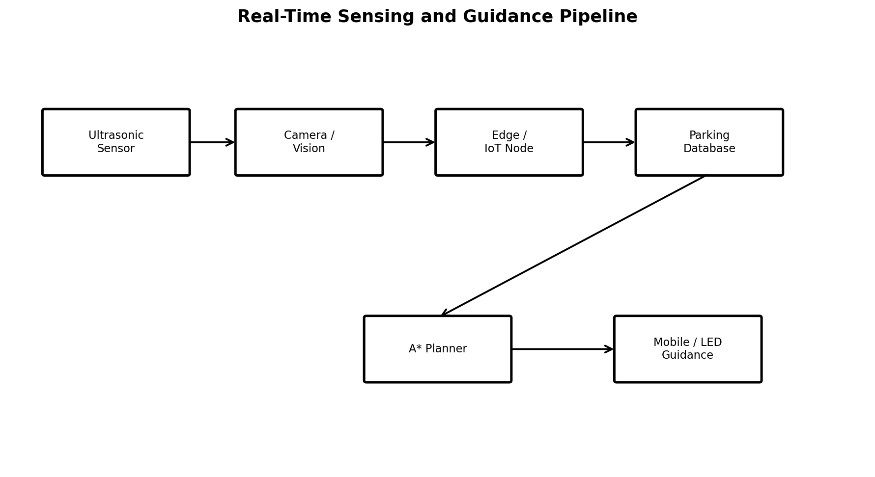

3.7 Software Technologies
Technology | Purpose
Python | Core prototype implementation
Priority Queue / Heap | Efficient A* open-set management
SQLite / MySQL | Parking and event data storage
Flask / FastAPI | Optional API for UI and mobile integration
HTML/CSS/JavaScript | Web dashboard and route visualization
Matplotlib | Testing and algorithm visualization
IoT protocol such as MQTT | Optional sensor event transport

3.8 Security Considerations
Administrative operations should require authentication. Sensor and API traffic should be protected when deployed beyond a local prototype. Access controls should distinguish driver, operator, and administrator privileges. Logs should record important changes such as manual slot overrides and route-map updates.

3.9 Parking Map Representation
The parking facility is converted into a graph G=(V,E). V represents locations such as entrances, intersections, lane turning points, and parking slots. E represents legal movements between those locations. Each edge has a cost. In the simplest case, cost equals physical distance. A richer model can add penalties for turns, congestion, ramps, narrow segments, or restricted areas.
For example, if a route segment has distance d and a congestion penalty p, the effective cost can be represented as c=d+p. If a lane is blocked, the edge is removed or assigned a very large cost so that A* will not use it.

3.10 Candidate Slot Selection
The system should not automatically choose the geometrically closest slot without considering reachability. Candidate filtering may use slot status, vehicle category, reservation rules, zone preference, and distance. After filtering, the planner can run A* for each candidate or use a multi-goal strategy. For a small prototype, planning to the nearest few eligible slots is practical.

3.11 Route Recalculation
When a sensor event changes a slot from available to occupied, the system checks whether that slot is the current destination. If yes, a replacement slot is selected and a new path is calculated. When a lane becomes blocked, the affected edge is disabled and the route is recalculated from the vehicle's latest known node.

3.12 Pseudocode
1. Receive current vehicle node and eligible slot list. 2. Build the current traversable graph. 3. For each candidate slot, run A* from the current node to the slot. 4. Compare route costs. 5. Select the lowest valid cost route. 6. Convert the node sequence into human-readable directions. 7. Monitor occupancy and obstacles. 8. Re-plan if the current route becomes invalid.

SYSTEM DESIGN AND IMPLEMENTATION

3.13 User Interface and Guidance
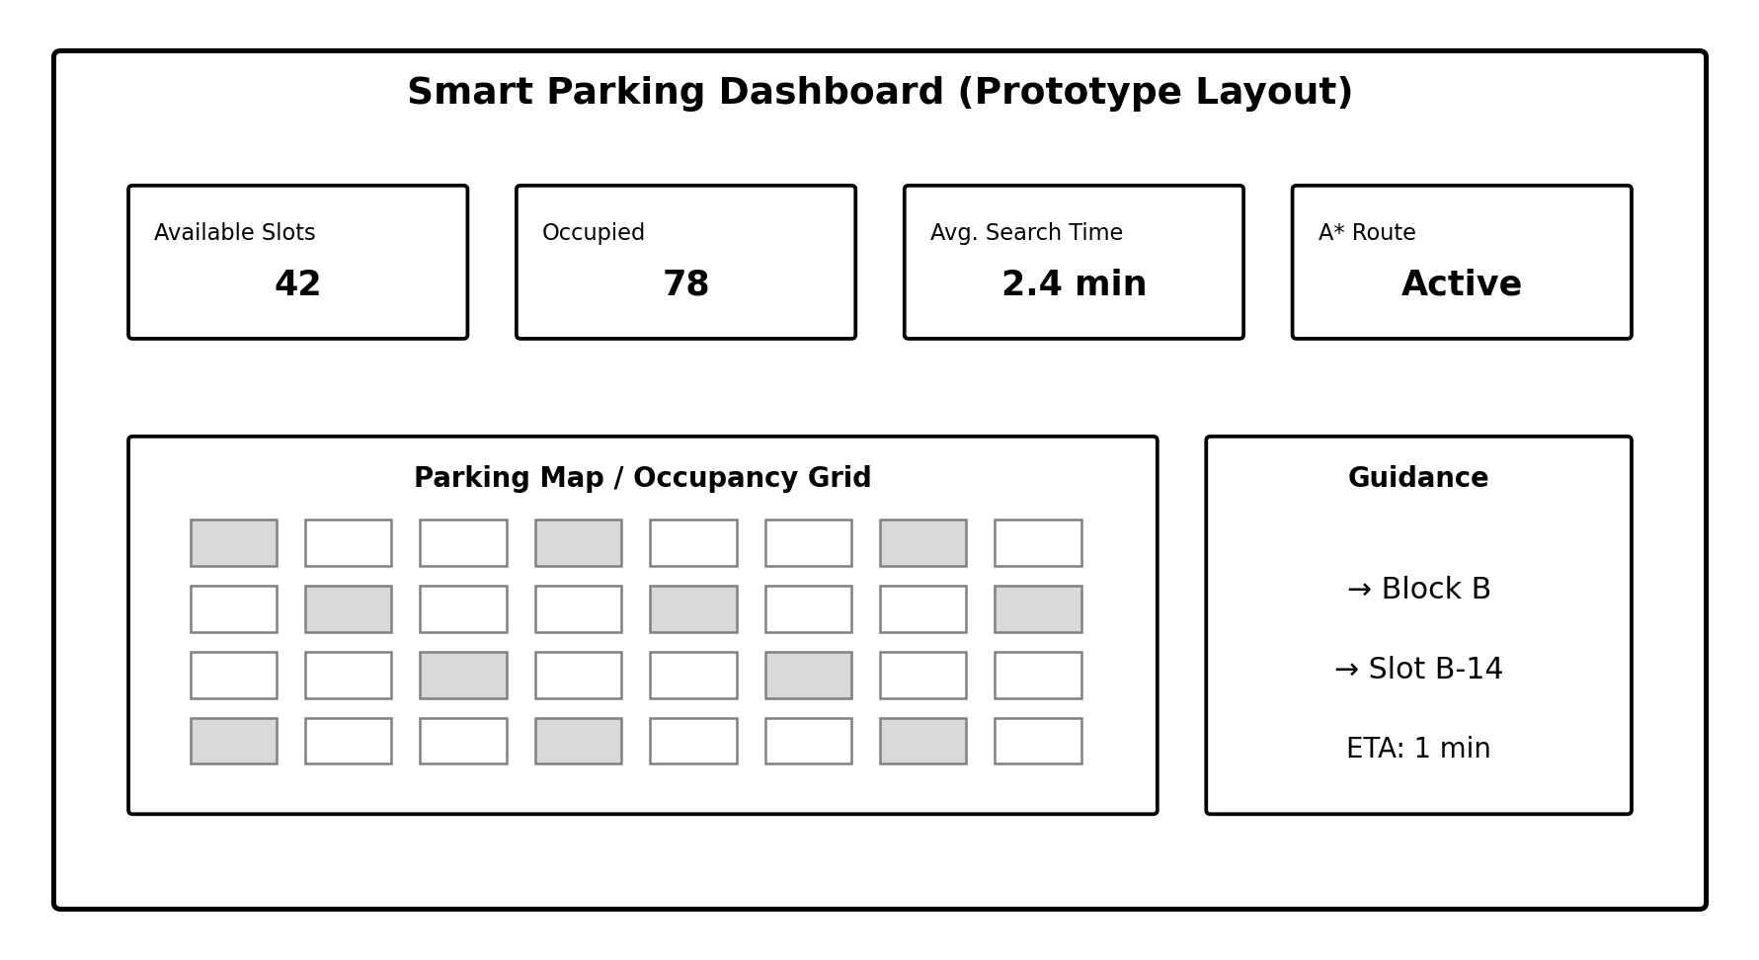
The user interface should communicate three pieces of information clearly: where to go, where to park, and whether the recommendation is still valid. A route can be represented visually on a map with arrows. For accessibility, the same information can be delivered as text, audio, or LED signage. The destination slot should be highlighted with a unique identifier such as B-14.

3.14 Example Guidance Sequence
- Vehicle enters through Gate A.
- System detects vehicle at node A0.
- Parking-state manager reports available slots B-11, B-14 and C-03.
- Rules remove reserved or unsuitable spaces.
- A* calculates routes to the remaining candidates.
- Slot B-14 has the lowest valid travel cost.
- Interface displays: “Proceed to Block B → Level 1 → Slot B-14.”
- If B-14 becomes occupied before arrival, the system selects the next valid slot and recalculates.

3.15 Implementation Modules
Module | Input | Output
sensor_simulator.py | Simulated occupancy events | Slot-state events
parking_db.py | Events and map records | Current state
graph.py | Nodes and edges | Search graph
astar.py | Start, goal, graph | Path and cost
rules.py | Slot/vehicle properties | Eligible destinations
guidance.py | Path nodes | Turn instructions
dashboard.py | State and route | Visual monitoring

CHAPTER 4
A* ALGORITHM AND REAL-TIME PATH PLANNING

4.1 A* Search Algorithm
A* is an informed search algorithm used to find a low-cost path between a start state and a goal state. It evaluates each candidate node using f(n)=g(n)+h(n), where g(n) is the cost from the start node to n and h(n) is a heuristic estimate from n to the goal. The algorithm maintains an open set of nodes that may be explored and a closed or processed set.
For a parking grid, Manhattan distance is suitable when vehicles move only horizontally and vertically: h(n)=|x_n-x_g|+|y_n-y_g|. For a map that permits diagonal movement, Euclidean or an appropriate movement-cost heuristic can be used. The heuristic should be selected so that it does not overestimate the remaining cost when optimality is required.
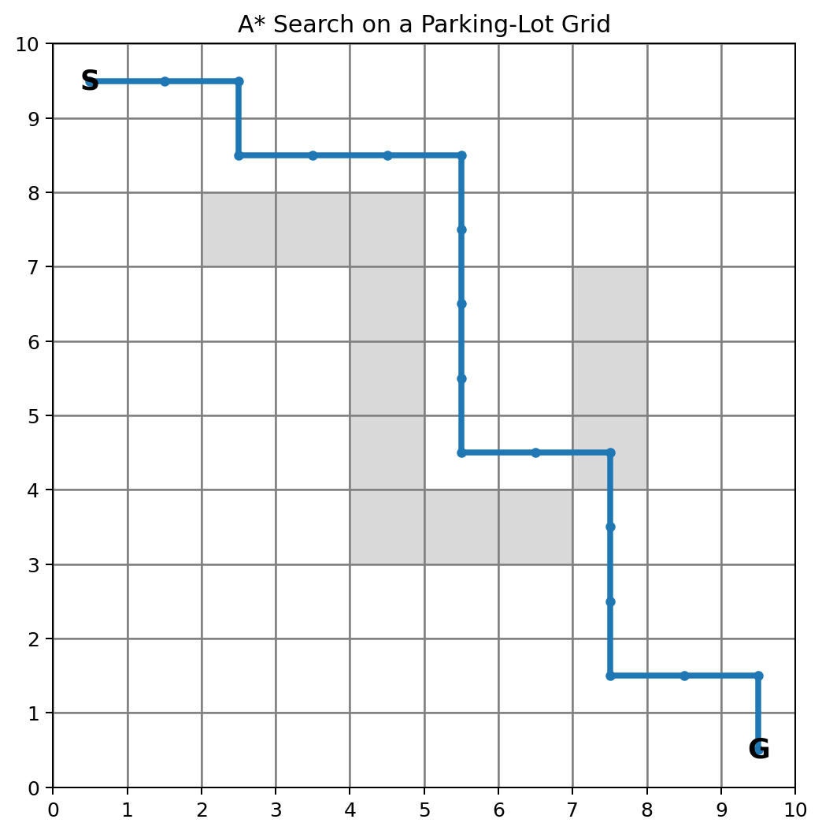

4.2 A* Procedure
- Initialize the start node with g=0 and calculate f=g+h.
- Insert the start node into the priority queue.
- Remove the node with the smallest f value.
- If it is the goal, reconstruct the path using parent pointers.
- For each valid neighbour, calculate a tentative g value.
- If the new path is better, update the neighbour's g, f and parent.
- Continue until the goal is reached or the open set becomes empty.

4.3 Heuristic Design
Environment | Possible Heuristic
4-direction grid | Manhattan distance
8-direction grid | Octile distance
Continuous coordinates | Euclidean distance
Weighted road network | Lower-bound travel-cost estimate
The heuristic has a direct effect on search performance. A heuristic that is informative but admissible can reduce the number of nodes explored while retaining optimality. In a parking facility, physical distance alone may not capture all costs, so a practical system can include congestion-aware edge costs while retaining a heuristic that remains a lower bound.

4.4 Dynamic Environment Handling
A standard A* run assumes that the graph remains unchanged during the search. Smart parking violates this assumption because slots and lanes can change state. The proposed implementation therefore uses repeated planning: obtain the latest state, plan, begin following the route, monitor events, and re-plan when a change invalidates the current route.

4.5 Route Cost Model
A configurable route cost can be defined as C(route)=distance + λ(turns) + μ(congestion) + ρ(restrictions). The coefficients λ, μ and ρ allow the parking operator to express preferences. For a basic academic prototype, the cost can initially be pure distance and later be extended with penalties.

4.6 Complexity Discussion
The exact computational complexity of A* depends on the graph and heuristic. In the worst case, the search can approach the behaviour of uninformed shortest-path algorithms, but a useful heuristic generally reduces exploration. In a typical parking map with hundreds or thousands of nodes, an efficient priority queue and a well-designed heuristic can support rapid route calculations.

4.7 Worked Example
Consider a vehicle entering at node E and three available slots S1, S2 and S3. The system first removes slots that are reserved, occupied, or inaccessible. Suppose S1 is closest by straight-line distance but requires passing through a congested lane, while S2 is slightly farther but has a shorter valid travel cost. A* calculates each route using the graph costs, and the decision layer selects the lowest valid result.
Candidate | Distance Cost | Penalty | Total Cost | Decision
S1 | 18 | 6 | 24 | Reject
S2 | 21 | 1 | 22 | Select
S3 | 27 | 0 | 27 | Reject
This example illustrates why a smart parking system should combine slot selection and path planning. A purely geometric nearest-slot method might select S1, while the integrated approach selects S2 because its actual travel cost is lower.

4.8 Route Instruction Generation
The raw A* result is a sequence of node identifiers. A guidance module converts this into instructions by examining the direction between consecutive nodes. A sequence may become “Continue straight, turn right at Junction J3, continue to Block B, enter Level 1, park at B-14.” This transformation improves usability without changing the search algorithm.

4.9 Re-Planning Trigger Conditions
- Destination slot changes to occupied.
- Required road segment changes to blocked.
- Vehicle deviates significantly from the planned route.
- New restriction or emergency event affects the route.
- Parking policy changes during the journey.

CHAPTER 5
RESULTS, TESTING AND DISCUSSION

5.1 Testing Strategy
Testing should cover both the correctness of A* and the behaviour of the complete parking workflow. Unit tests verify the graph, heuristic, queue handling, path reconstruction, occupancy updates, and eligibility rules. Integration tests verify that an occupancy event can affect candidate selection and route planning.
Test ID | Scenario | Expected Result
T01 | Start and goal are adjacent | Direct path returned
T02 | Obstacle blocks direct path | Alternative path returned
T03 | Goal is occupied | Occupied slot is not selected
T04 | Lane becomes blocked | Route is recalculated
T05 | No slot is available | System reports no valid destination
T06 | Vehicle requests accessible slot | Only eligible slots considered
T07 | Sensor update is stale | System avoids unsafe immediate selection
T08 | Multiple candidates | Lowest valid route cost selected

5.2 Performance Measures
Important measures include route-planning time, number of nodes expanded, route distance, route cost, re-planning time, percentage of successful destination selections, occupancy utilization, and average driver search time. These measures allow the prototype to be evaluated without claiming that one metric alone defines system quality.

5.3 Illustrative Evaluation Framework
The following table is an evaluation template for the implemented prototype. Values should be replaced by measurements obtained from the actual experiment; the table is not presented as a claim of measured real-world performance.
Metric | Purpose | Example Reporting Format
Average A* planning time | Measures computational responsiveness | ___ ms
Average route length | Measures travel efficiency | ___ m
Nodes expanded | Measures search effort | ___ nodes
Re-plan time | Measures dynamic response | ___ ms
Successful slot selection | Measures functional reliability | ___ %
Average search time | Measures user benefit | ___ min
Occupancy accuracy | Measures sensing quality | ___ %

5.4 Expected Behaviour
The system is expected to produce a valid route when at least one eligible slot is reachable. When obstacles are added, the path should change while avoiding blocked edges. When the destination becomes occupied, the system should select another candidate rather than continuing to direct the driver to an invalid slot. These behaviours are more important to the prototype's intelligence than simply displaying a static shortest path.

5.5 Discussion
A* is appropriate because parking navigation is naturally represented as a graph search problem. Its main advantage is that the heuristic guides exploration toward the destination instead of blindly exploring all alternatives. However, the quality of the result depends on the map, edge costs, occupancy data, and heuristic. Therefore, the complete system should be evaluated as an integrated sensing-and-planning pipeline.

CONCLUSION AND FUTURE ENHANCEMENT

6.1 Conclusion
The project presents the design and implementation approach for an Intelligent Smart Parking Guidance System using A* search for real-time path planning. The system treats a parking facility as a dynamic graph, maintains slot availability, applies expert-style rules to identify suitable destinations, and uses A* to compute an efficient path. The proposed architecture connects sensing, data management, AI search, route generation, and user guidance.
The key strength of the design is the integration of real-time information with classical AI. Instead of selecting a parking slot independently from navigation, the system evaluates whether the slot is reachable and how much travel cost is required. This provides a more meaningful recommendation for drivers.

6.2 Limitations
- Prototype occupancy may rely on simulated data rather than calibrated physical sensors.
- The basic A* implementation plans for one vehicle at a time.
- Highly dynamic congestion may require more advanced predictive or incremental planning.
- Indoor positioning may require additional hardware for accurate vehicle localization.
- Real-world deployment requires extensive safety, networking, security and hardware validation.

6.3 Future Enhancements
- Computer-vision based parking occupancy detection.
- Mobile application with live map and turn-by-turn navigation.
- Multi-vehicle coordination and congestion prediction.
- Hierarchical A* or incremental search for large facilities.
- Machine-learning models for parking-demand prediction.
- Automatic reservation and payment integration.
- EV charging-slot management and energy-aware routing.
- Voice guidance and accessibility-aware route selection.
- Cloud analytics for occupancy trends and facility optimization.

REFERENCES
1. Russell, S. and Norvig, P., Artificial Intelligence: A Modern Approach, Pearson.
2. Hart, P. E., Nilsson, N. J., and Raphael, B., “A Formal Basis for the Heuristic Determination of Minimum Cost Paths,” IEEE Transactions on Systems Science and Cybernetics.
3. Cormen, T. H., Leiserson, C. E., Rivest, R. L., and Stein, C., Introduction to Algorithms, MIT Press.
4. Geeks/educational documentation may be used for prototype-level Python data-structure reference; academic claims should be supported by textbooks or peer-reviewed literature.
5. Python Software Foundation, Python documentation, for language and standard-library implementation reference.
6. MQTT specification and documentation, for optional IoT event communication design.
7. General smart-parking and intelligent-transportation research literature may be consulted to compare sensing technologies, occupancy detection, and user guidance approaches.

Suggested Keywords for Further Literature Review
- Smart parking system
- Parking occupancy detection
- A* path planning
- Intelligent transportation systems
- IoT parking sensors
- Dynamic shortest path
- Heuristic search
- Expert systems
- Real-time navigation
- Computer vision for parking

APPENDICES

APPENDIX A – SAMPLE A* PSEUDOCODE

function A_STAR(start, goal):
open_set ← priority queue
g[start] ← 0
f[start] ← heuristic(start, goal)
push start into open_set
while open_set is not empty:
current ← node with smallest f
if current = goal: return reconstruct_path(current)
for each neighbour of current:
if edge is blocked: continue
tentative_g ← g[current] + edge_cost(current, neighbour)
if tentative_g < g[neighbour]:
parent[neighbour] ← current
g[neighbour] ← tentative_g
f[neighbour] ← g[neighbour] + heuristic(neighbour, goal)
push neighbour into open_set
return failure

APPENDIX B – SAMPLE DATABASE RECORDS
SlotID | Zone | Type | Status | LastUpdated
A-01 | A | Regular | Available | 09:30
A-02 | A | Accessible | Occupied | 09:30
B-14 | B | Regular | Available | 09:30
B-15 | B | EV | Available | 09:29
C-03 | C | Reserved | Reserved | 09:28

APPENDIX C – SAMPLE PROJECT MODULE STRUCTURE
smart_parking/
data/
parking.db
src/
sensor_simulator.py
parking_db.py
graph.py
astar.py
rules.py
guidance.py
dashboard.py
tests/
test_astar.py
test_occupancy.py
test_rules.py
README.md

APPENDIX D – PROJECT OUTPUTS TO INCLUDE DURING FINAL DEMO
- Parking occupancy dashboard screenshot.
- A* search visualization with start, goal, obstacles and selected path.
- Before/after route screenshots showing re-planning.
- Console output showing route cost and planning time.
- Test-case results and performance table.
- Photographs of any physical sensor prototype, if implemented.

OUTPUT: Hardware
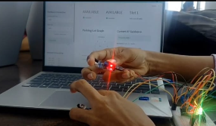
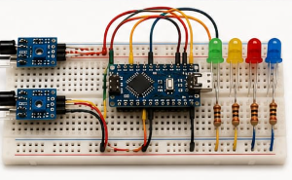
Proof:


